6.1 CI with Junit in Jenkins

This section will guide you to:
- Connect Git and GitHub repository with Jenkins along with Junit tests.

This guide has four subsections, namely:
6.1.1 Login to Jenkins
6.1.2 Add Junit dependencies and classes in Maven project
6.1.3 Create Jenkins job for Maven
6.1.4 Push code to GitHub repositories

Step 6.1.1: Login to Jenkins
- Open your browser and navigate to localhost:8081
- Provide your username and password and click on Login.
Step 6.1.2: Add Junit dependencies and classes in Maven project.
Create a maven project by executing the following command
mvn archetype:generate -DgroupId=jenkinsDemo -DartifactId=jenkinsDemo -DarchetypeArtifactId=maven-archetype-quickstart -DinteractiveMode=false

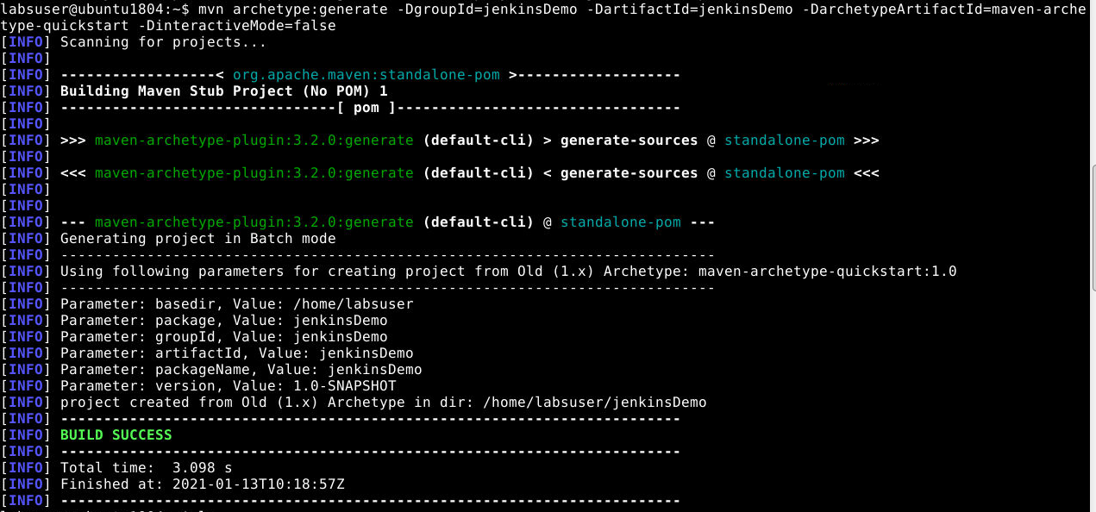

Run the below command to navigate inside the maven project.

cd jenkinsDemo

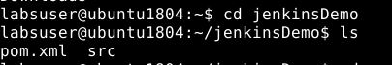

- Add the below code in the pom.xml file of your Maven project.
<dependencies>
<dependency>
<groupId>junit</groupId>
<artifactId>junit</artifactId>
<version>4.12</version>
</dependency>
<dependency>
<groupId>org.seleniumhq.selenium</groupId>
<artifactId>selenium-java</artifactId>
<version>3.10.0</version>
</dependency>
</dependencies>

- Delete the src/main folder and Navigate to src/test/java and create a file JenkinsDemo.java
- Add the following code in JenkinsDemo.java
import org.junit.After;
import org.junit.Assert;
import org.junit.Before;
import org.junit.Ignore;
import org.junit.Test;
import org.openqa.selenium.By;
import org.openqa.selenium.WebDriver;
import org.openqa.selenium.chrome.ChromeDriver;
/**
* Created by
* Sample junit test code to integrate by
*/
public class JenkinsDemo
{
private static String Base_Url = "https://www.facebook.com";
private WebDriver driver;
@Before
public void setUp()
{
driver = new ChromeDriver();
driver.get(Base_Url);
}
@After
public void after()
{
driver.quit();
}
@Test
public void testCasePassed()
{
Assert.assertTrue(driver.findElement(By.xpath("//form[@id='login_form']")).isDisplayed());
}
@Test
public void testCaseFailed()
{
Assert.assertTrue(driver.findElement(By.xpath("//form[@id='failed case']")).isDisplayed());
}
@Ignore
@Test
public void testCaseIgnored()
{
Assert.assertTrue(driver.findElement(By.xpath("//form[@id='ignored case']")).isDisplayed());
}
}
Your directory structure should only have these files. Delete any unnecessary files or folder structures.
Step 6.1.3: Create Jenkins job for Maven

- To create a new job in Jenkins, open the Jenkins dashboard with your Jenkins URL. For example, http://localhost:8081/.
- Click on Create New Job. Enter the item name, select Maven Project, and click OK.
- Once you click OK, the page will be redirected to its project form. Here, you will need to enter the project information.
- In the Build section of your job, give the path of the pom.xml in your local system. ie. /home/labuser/jenkinsDemo/pom.xml
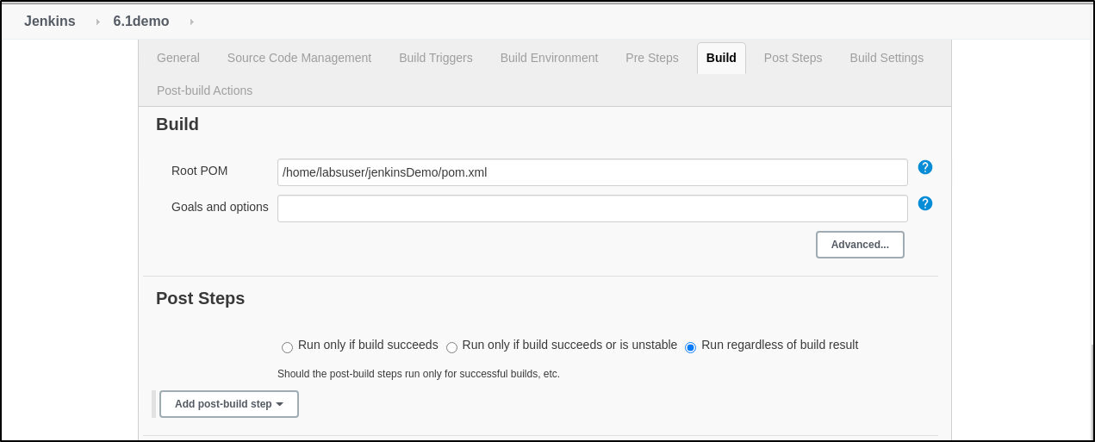
- Build the job and check the status on the console for the test cases executed.

Step 6.1.4: Push the code to your GitHub repositories

- Open your command prompt and navigate to the folder where you have created your files.
cd <folder path>
- Initialize your repository using the following command:
git init
- Add all the files to your Git repository using the following command:
git add .
- Commit the changes using the following command:
git commit . -m “Changes have been committed.”
- Push the files to the folder you initially created using the following command:
git push -u origin master

